**Chapter 5: Pressure and Deformation in Solids**

**All Lectures Uploaded on YouTube:** [**https://tinyurl.com/fkm9-physics**](https://tinyurl.com/fkm9-physics)



Matter is made up of atoms and molecules. Applying external forces like weight, pressure, heat, etc., causes the deformation of the matter, which in turn changes the matter’s shape, dimension, and orientation. 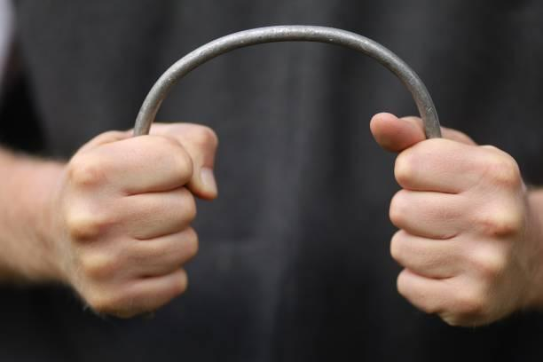

Solid matter is made up of atoms and molecules which are packed closely. Because of this property of solids, they retain their original shapes easily, and the atoms or molecules return to equilibrium after removal force.

In the case of liquid and gaseous matter, the atoms and molecules are loosely packed, and the deformation of this matter takes less force as compared to solids. Liquids and gaseous matter do not retain their equilibrium state unless an external force is applied again.

## 5.1 Elasticity

**‘The ability of a deformed body to return to its original shape and size when the deforming forces are removed is called elasticity’.**

Elasticity is the property of a material to regain its original shape and size after the deforming force is removed. For example, a rubber band stretches under force but returns to its original form when the force is released. The concept of elasticity is vital in engineering, as it determines the safety and durability of materials under load.

### 5.1.1 Hooke’s Law

**When a spring is stretched or compressed (within elastic limit), the extension or compression is directly proportional to the applied force.**

Hooke’s Law states that the extension (or compression) of a spring is directly proportional to the restoring force, $F_{res}$, as long as the elastic limit is not exceeded.

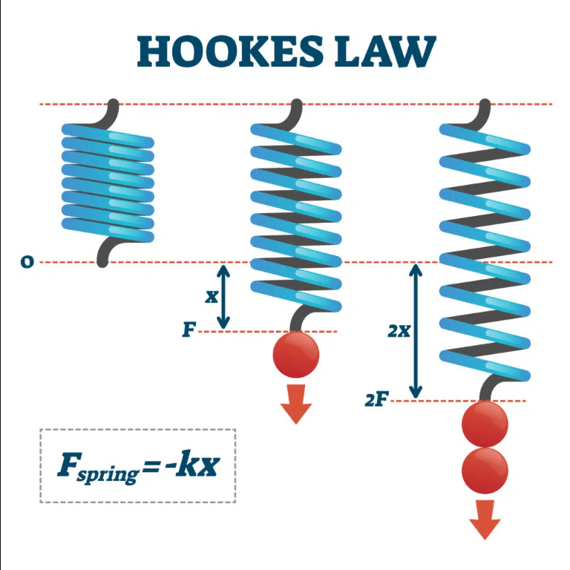

Mathematical form: $F_{res} ∝-x or F_{res}= -kx$

Therefore, $k= \frac{-F_{res}}{x}$

Where:

* F = Force applied (**N**)
* k = Spring constant (**N/m**)
* x = Extension or compression (**m**)

The spring constant (k) represents the stiffness of the spring. **The unit is newtons per meter (N/m)**.

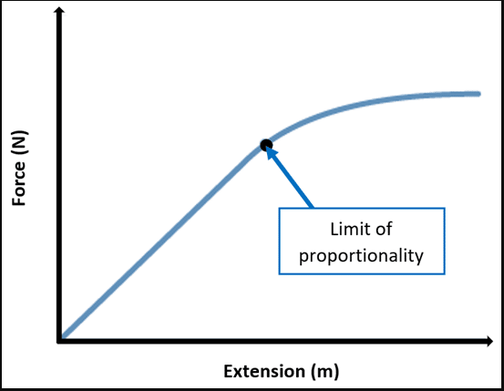

### 5.1.2 Applications of Hooke’s Law

Hooke’s Law has many practical applications, such as: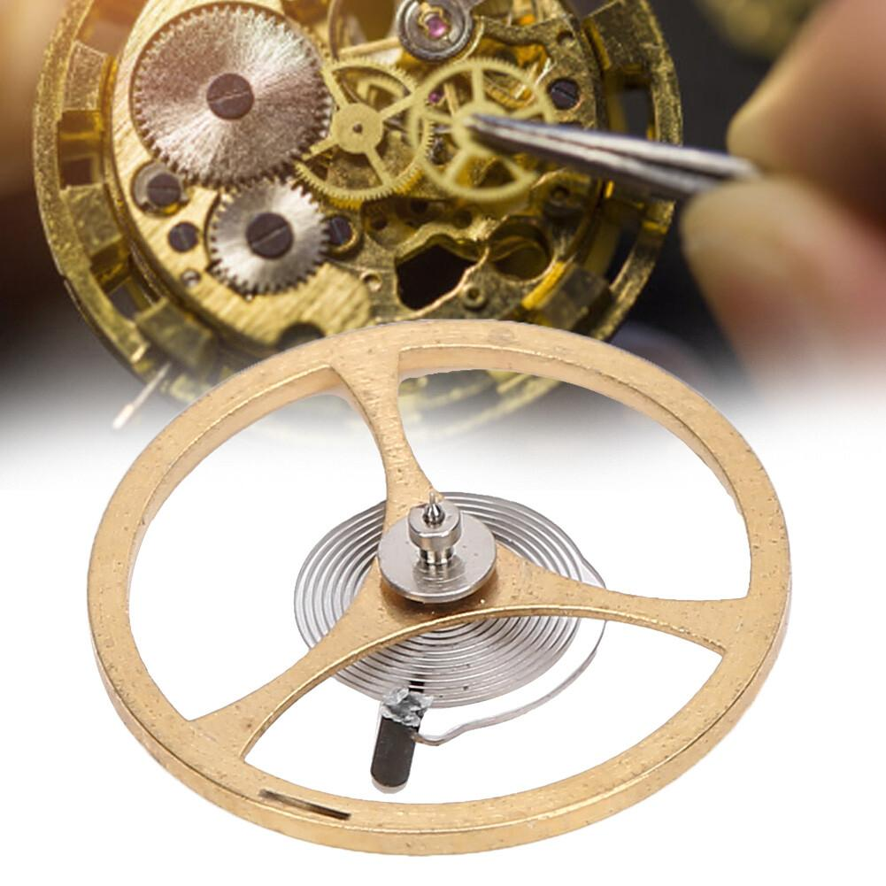

* **Balance Wheel of Mechanical Watches:** A balance wheel is the timekeeping device used in mechanical watches. It is a weighted wheel that rotates back and forth, being returned toward its center position by a spiral torsion spring or hairspring as shown in figure. The balance spring oscillates and keeps accurate time.
* **Spring Scale:** It measures weight or force using calibrated spring displacement. This device is mainly used to weigh items or objects by connecting them to a hook at its bottom as shown in the figure below:

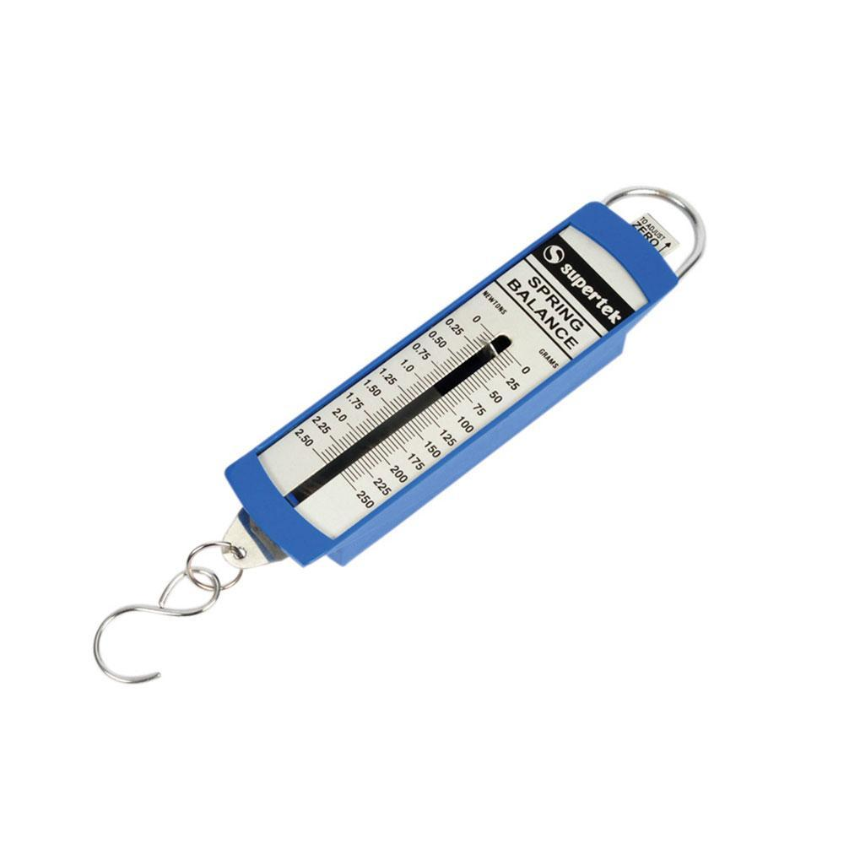

* **Galvanometer**: Galvanometer is a device used for detecting current or voltage. It makes use of the hair spring which not only electrical connection to coil and restoring the pointer back, but also make the deflection proportional to the force according to Hooke’s law as shown in figure.

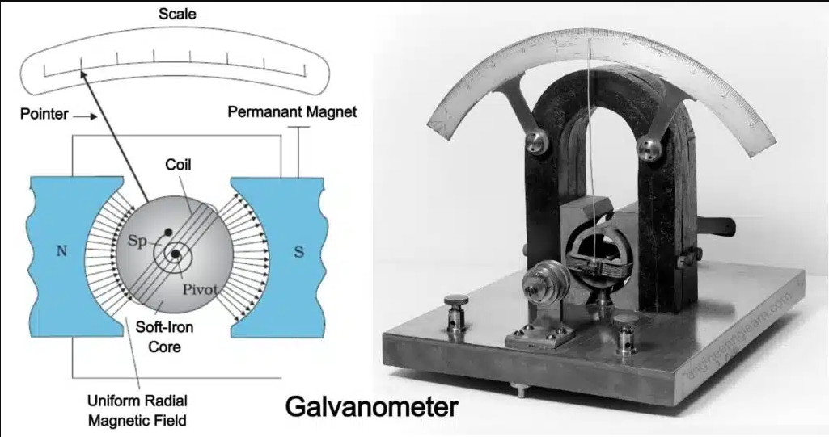

**Stress-Strain Curves**: Initially stress is proportional to strain (Hooke’s region). Beyond the elastic limit, permanent deformation occurs until the breaking point.

* The **limit of proportionality**, the limit up to which Hooke’ law is obeyed is called the proportional limit.
* The **elastic limit** is the limit up to which material shows elastic behavior also called yield strength.
* The **maximum stress** a material can bear before fracture (breaking) is called ultimate stress or ultimate strength.
* The **breaking point** is where material breaks.

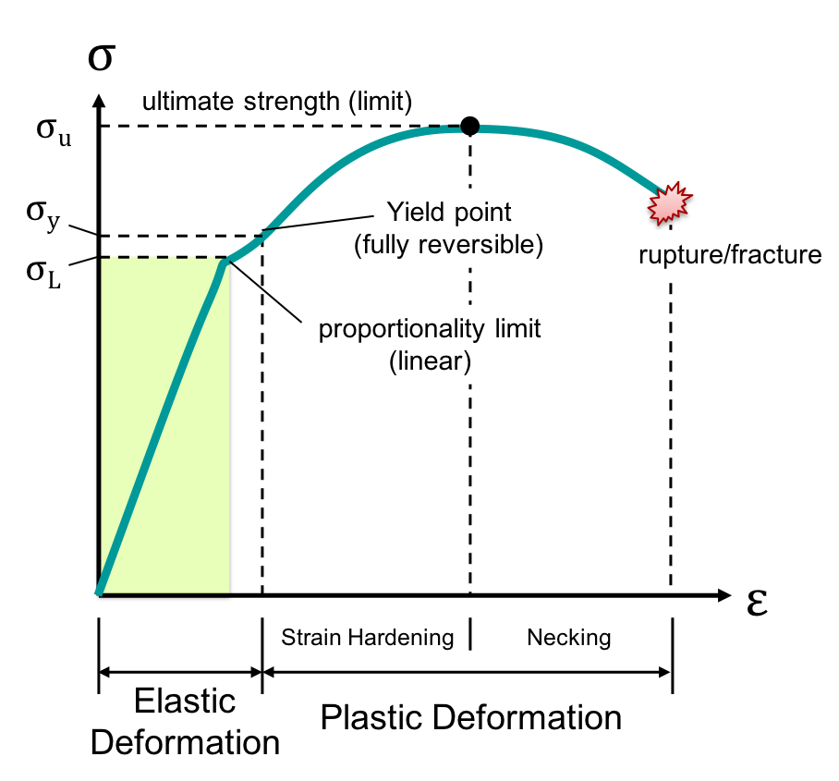

## 5.2 Pressure

Pressure is defined as the force applied normally on a surface per unit area. It is expressed mathematically as: $P=\frac{F}{A}$ 
  
Where P = Pressure (**Pa**), F = Force (**N**), A = Area (**m²**).

Unit: Pascal (**Pa**), where 1 Pa = 1 N/m².

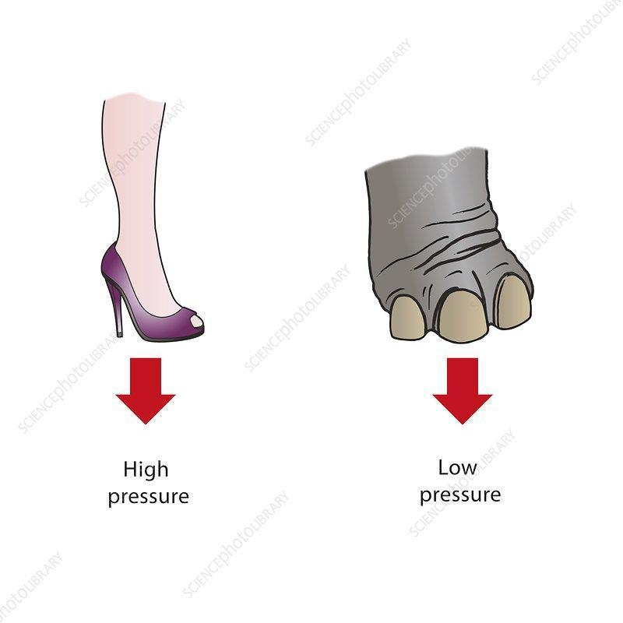

## 5.3 Atmospheric Pressure

‘The pressure that atmospheric particles exert on the surface of earth and all over the surface of objects on the earth is called atmospheric pressure’.

Atmospheric pressure is the force exerted by the weight of the air column above the Earth’s surface. At sea level, it is **1.013 × 10⁵ Pa** (or 760 mmHg). This pressure supports life and affects weather.

$1 atm =1.013 × 10⁵ Pa$

Another unit of pressure sometimes used (in meteorology and on weather maps) is the bar, which is defined as

$1 bar=1.000 × 10⁵ Pa$

### 5.3.1 Measurement of Atmospheric Pressure

A liquid barometer is a device that measures atmospheric pressure using the principles of hydrostatics and the behavior of liquids. Two types of barometers are used:

* Liquid Barometer: Uses water; impractical due to large height required.
* Mercury Barometer: Compact due to mercury’s high density; widely used.
* Applications:   
   A. **Altitude Measurement**: Liquid barometers can estimate altitude. As atmospheric pressure decreases with increasing altitude, the height of the mercury column decreases, allowing for altitude calculations.   
   B. **Weather Forecasting**: They are used in meteorology to measure atmospheric pressure, which is associated with weather changes. A falling barometer may indicate an approaching storm, while a rising barometer suggests improvement in weather conditions.   
   C. **Industrial Applications**: Used for precise measurements.

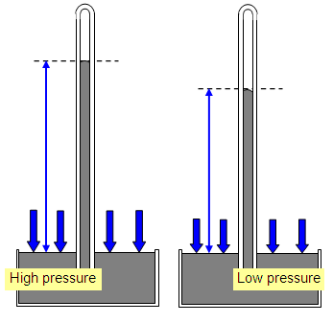

### 5.3.2 Atmospheric Pressure and Height from Earth Surface

Atmospheric pressure decreases with increasing altitude, leading to lower oxygen levels. This is important in aviation and mountaineering.

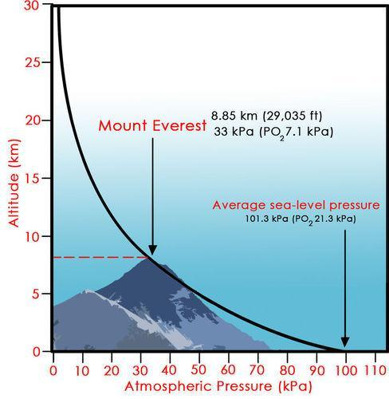

### 5.3.3 Atmospheric Pressure and Weather

Atmospheric pressure variations predict weather. High pressure indicates fair weather, while low pressure indicates storms or rain.

Barometers that are kept in the same place at the same height above sea level show some variation in atmospheric pressure from day to day. These pressure variations are shown on weather maps:

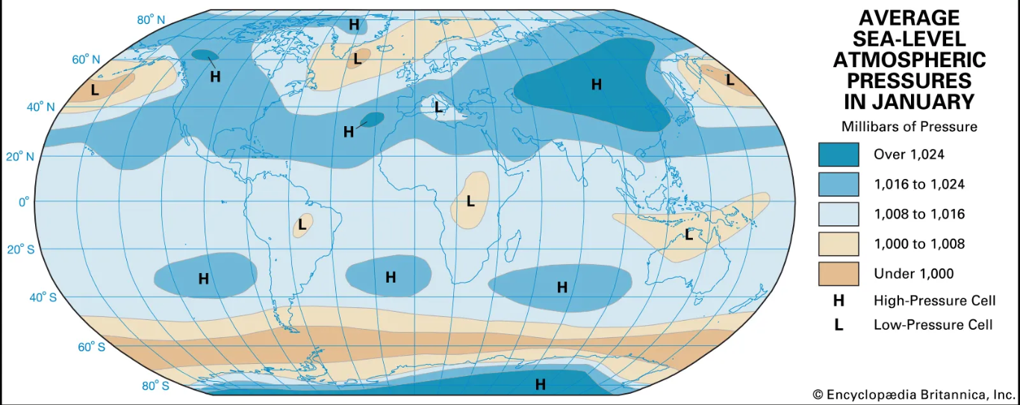

### 5.3.4 Applications of Atmospheric Pressure

Examples include: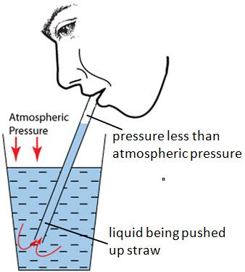

* Drinking by Straw: Liquid rises due to external atmospheric pressure. The action of sucking increases the volume of lungs, thereby reducing the air pressure in the lungs and the mouth. The atmospheric pressure acting on the surface of the liquid will then be greater than the pressure in the mouth, thus forcing the liquid to rise up the straw into the mouth.
* Drawing Liquid by Syringe: Reduced internal pressure allows liquid to flow in. When the piston of the syringe is drawn back upwards. This decreases the pressure within the cylinder.

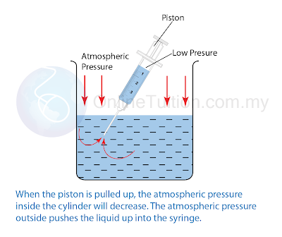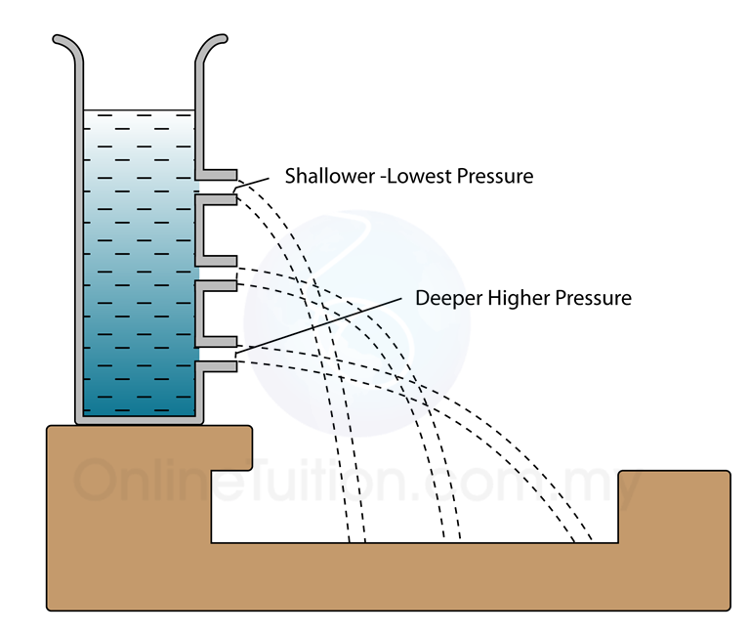

## 5.4 Liquid Pressure

The pressure exerted by a liquid at a depth depends on the liquid’s density, gravity, and depth. Mathematically,

$P=ρgh$,

where ρ = density (**kg/m³**), g = gravitational acceleration (**m/s²**), h = depth (**m**).

**Factors:** Liquid pressure increases with depth and density but does not depend on the container’s shape.

## 5.5 Manometer

A manometer is a device used to measure the pressure of fluids using a liquid column. It works on the principle of balancing liquid pressure against fluid pressure. The fluid can be a gas or a liquid.

The working principle of a manometer is that one end is connected to a seal-tight gas to measure the source of pressure. Whereas, its other end is left open to the atmospheric pressure of the earth. 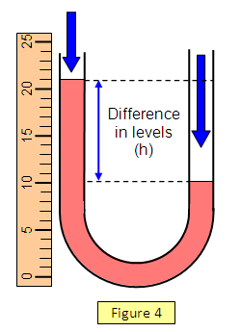

Formula: $P=ρgh$

* Applications include:
  + It is used to measure the pressure of the fluids using mechanical properties of fluids.
  + It is also used to measure vacuum.
  + It is also used to measure the flow of the fluid.
  + It is used to measure the filter pressure drop of the fluids.
  + It is also used for meter calibrations.
  + It is used to measure leak testing.
  + It is also used to measure the liquid level present in a tank.

| **DIFFERENCES BETWEEN MANOMETER AND BAROMETER** | |
| --- | --- |
| **Manometer** | **Barometer** |
| It is a device that is used to measure the pressure of the fluid but that of a liquid concerning the earth’s atmospheric pressure. | It is a device that is used to measure fluid pressure but that of air as it can differ with distance when it’s below or above sea level |
| It comes in different forms | It comes only in one basic design for all its types |
| These are filled with mercury or any heavy liquid material but in some cases, they can be filled with a lighter liquid material | In all its cases, these are only filled with mercury or any heavy liquid material |

## 5.6 Pascal’s Principle

Pascal’s Principle states that when pressure is applied to an enclosed fluid, it is transmitted equally and undiminished in all directions. This is the basis for hydraulic machines.

Since pressure is transmitted equally in all directions, the force generated ($F=P×A$) is also distributed equally in all directions. The force acts perpendicular to the surface because the pressure is acting uniformly in all directions.

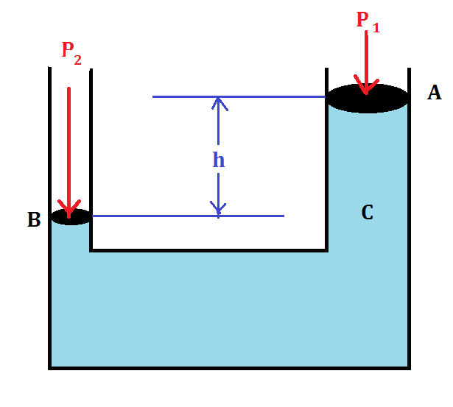

### 5.7.1 Hydraulic Lift

Hydraulic lifts use Pascal’s Principle to lift heavy objects. A small force applied on a small piston produces pressure, which is transmitted to a larger piston, lifting heavy loads with ease.

Formula: $\frac{F_{2}}{F_{1}}=\frac{A_{2}}{A_{1}}$

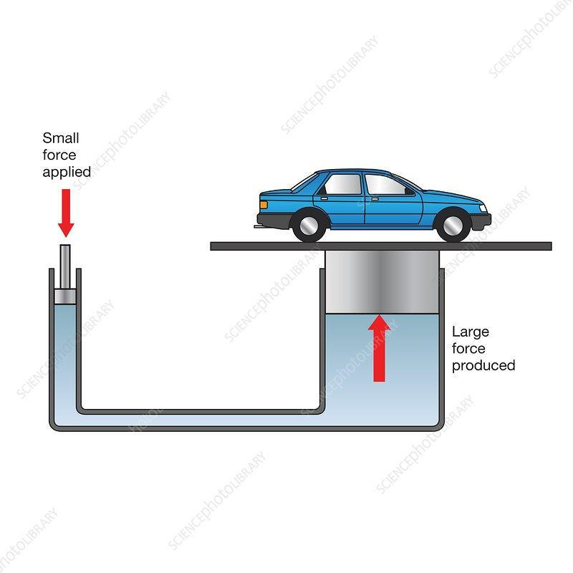

### 5.7.2 Hydraulic Car Brake System

The car brake system is based on Pascal’s Principle. When the driver presses the brake pedal, the applied force is transmitted as pressure through brake fluid to all wheels, applying brakes uniformly.

* Main Components:
  + **Brake Pedal (Force Input):** When we press the brake pedal, it exerts force on the master cylinder's piston.
  + **Master Cylinder (Pressure Increase):** The force on the piston increases the pressure in the brake fluid.
  + **Brake Lines (Pressure Transmission):** The increased pressure is transmitted equally through the brake fluid in the brake lines to all wheels.
  + **Brake Calipers or Wheel Cylinders (Force Application):** At eachwheel, the pressure acts on brake calipers or wheel cylinders, applying force to brake pads.

